Home Assignment week2 day1:
A. Try prompting using TL;DR and ELI-15 and observe the difference in output.
When tried Mobile Automation concept in gemini it returned 3 pages so tried, TL;DR Android Automation
Here is the quick TL;DR on Android Automation based on its two main flavors:
1. Mobile App Testing (For QA/Devs)
- Automatically controlling an app to catch bugs across different devices.
- Appium: The most popular open-source, cross-platform framework (supports Java, Python, JS, etc.).
- Espresso & UI Automator: Google's native, high-speed testing tools built specifically for Android.
- Mobilewright: An emerging tool (often compared to Appium) designed to simplify mobile test scripts, much like Playwright did for web testing.
2. Task Automation (For Users)
- Making your phone perform smart actions based on triggers (location, time, Bluetooth connections).
- Tasker & MacroDroid: Power-user apps to build complex "If This, Then That" routines on your device.
- ADB (Android Debug Bridge): Controlling or scripting your phone directly from a computer terminal via command lines.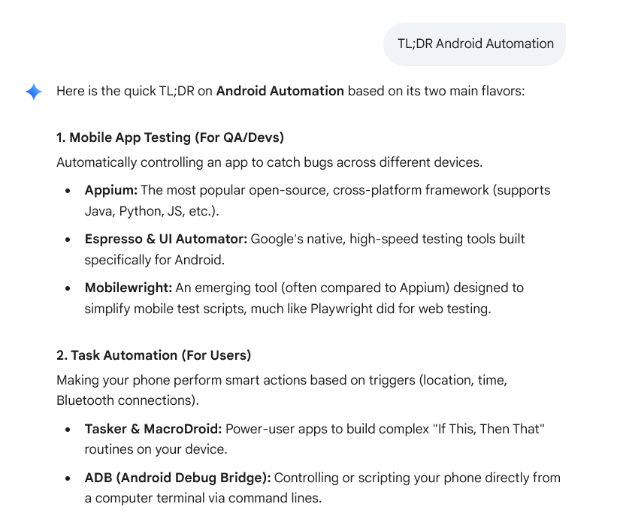
3.ELI 15 Android Automation:
Think of Android automation like giving your phone a smart checklist so it can run itself. Instead of a human tapping the screen, a computer script or an app does the work.
Depending on what you want to achieve, it usually falls into two buckets:
1. The QA/Developer Side (Testing Apps)
Imagine you just built a new social media app. You need to make sure the "Like" button works on 500 different types of Android phones. Tapping it manually on every single device would take forever.
Instead, developers use automation tools to write code that says: "Open the app, find the button with the ID 'like_button', and click it."
- Appium: The most popular tool. It acts like a universal remote control, letting you write scripts in languages like Python or Java to control the phone.
- Mobilewright: A newer, modern tool that makes writing these phone-controlling scripts much simpler and faster (similar to how Playwright changed web testing).
- Espresso: Google's built-in tool that tests apps at lightning speed from the inside out.
2. The Personal Side (Smart Phone Routines)
This is automation for everyday life. You don't need to know how to code; you just set up "If This, Then That" rules directly on your device.
- The Triggers: Your phone constantly monitors things like your GPS location, time of day, battery level, or Bluetooth connections.
- The Actions: Apps like Tasker or MacroDroid let you plug into those triggers.
Example: IF my phone connects to my car's Bluetooth AND it's between 8:00 AM and 9:00 AM, THEN automatically max out the media volume, open Spotify, play my morning playlist, and launch Google Maps.
How does the computer actually talk to the phone?
It uses a tool called ADB (Android Debug Bridge). Think of ADB as a digital pipeline between your computer terminal and your phone. By typing commands into your computer, you can force the phone to tap coordinates, type text, or open apps without ever touching the screen.
